**TO HIEN THANH PRIMARY SCHOOL**

**INTENSIVE ENGLISH PROGRAMME**

**FAMILY & FRIENDS 2 (Special Edition)– WEEK 23**

**UNIT 9: LUNCHTIME!**

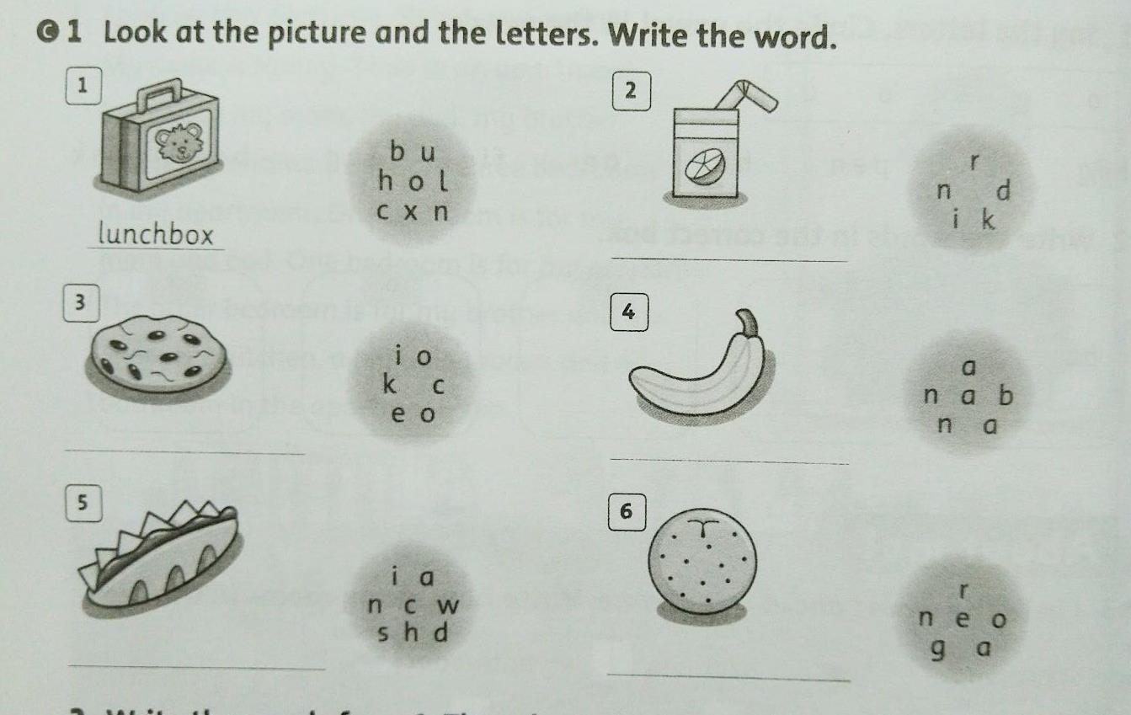**LESSON 1**

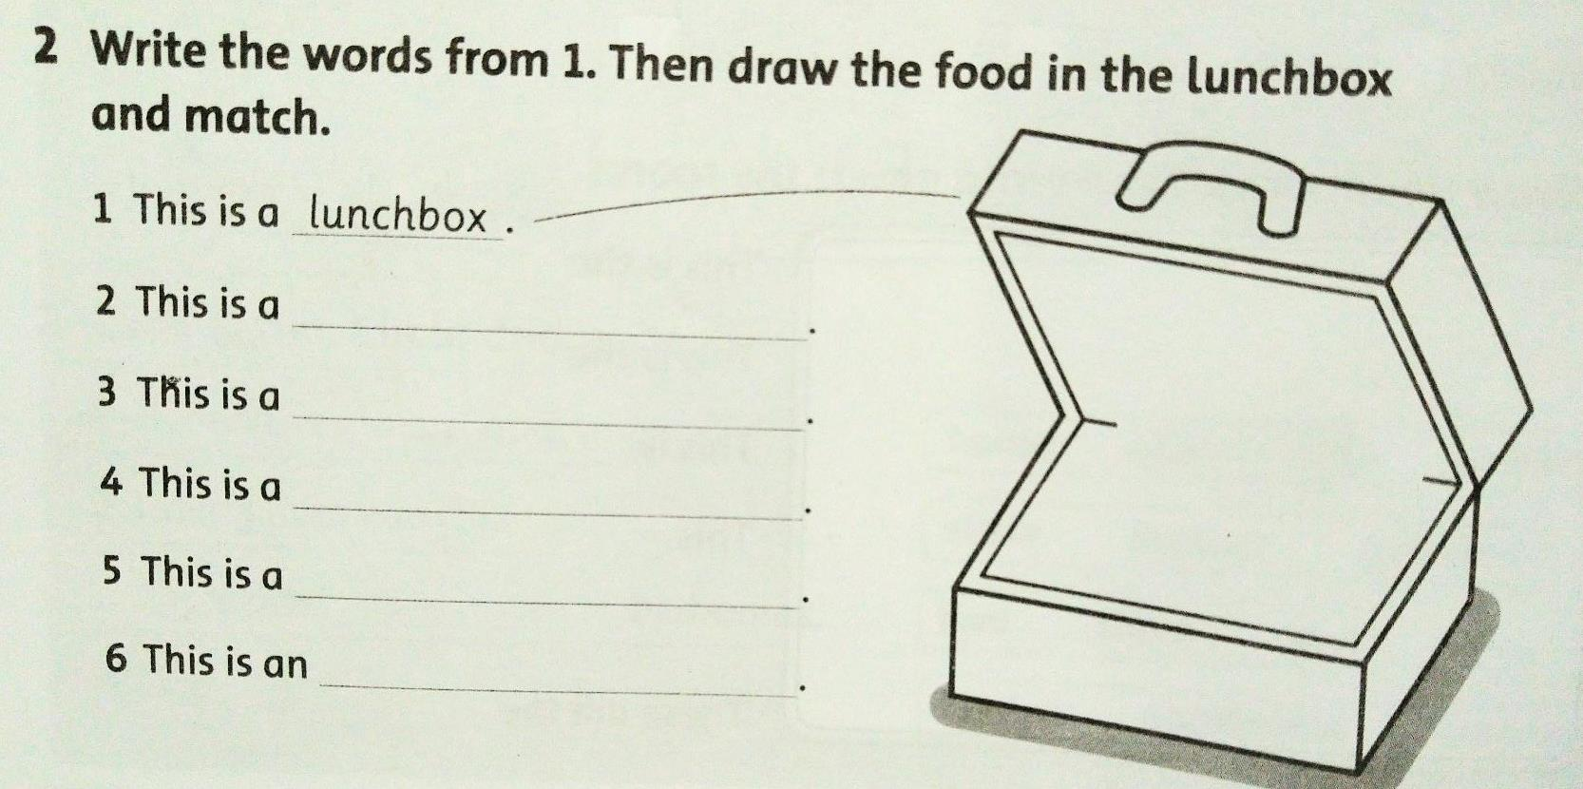

**LESSON 2**

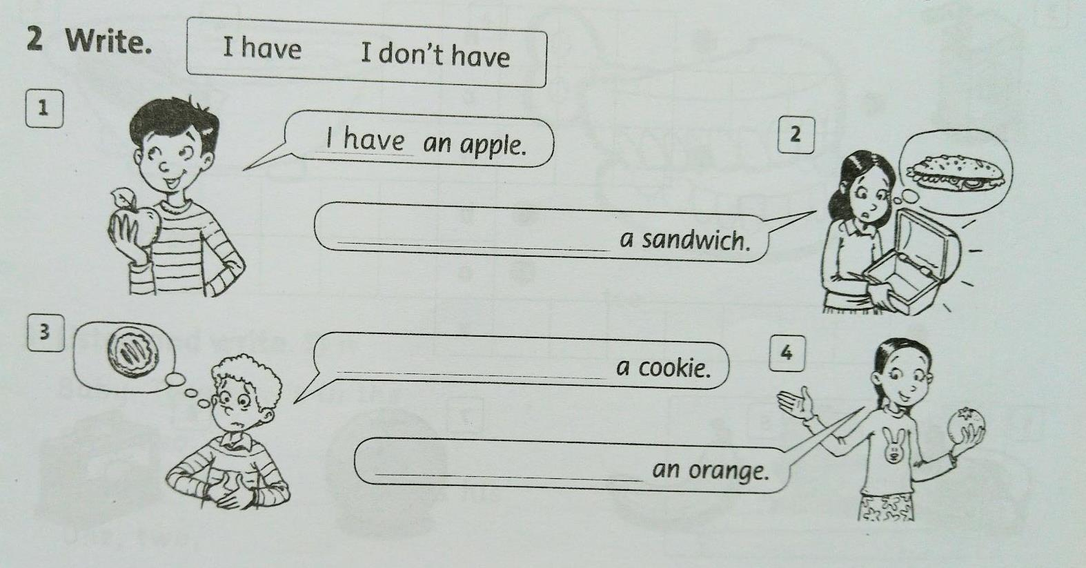

**LESSON 3**

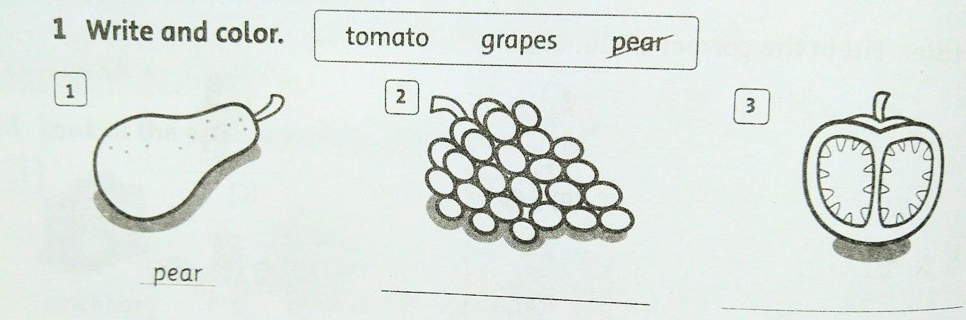

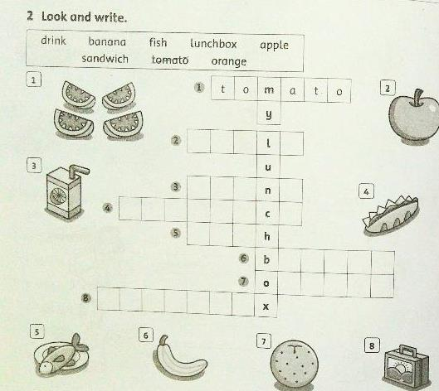

**LESSON 4**

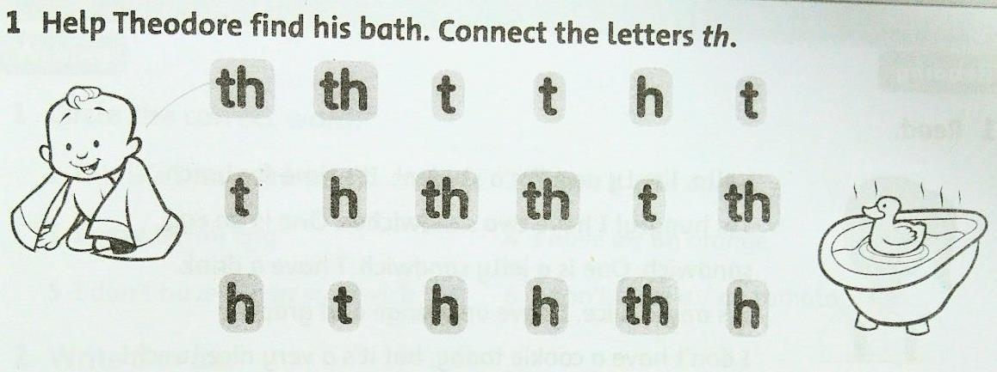

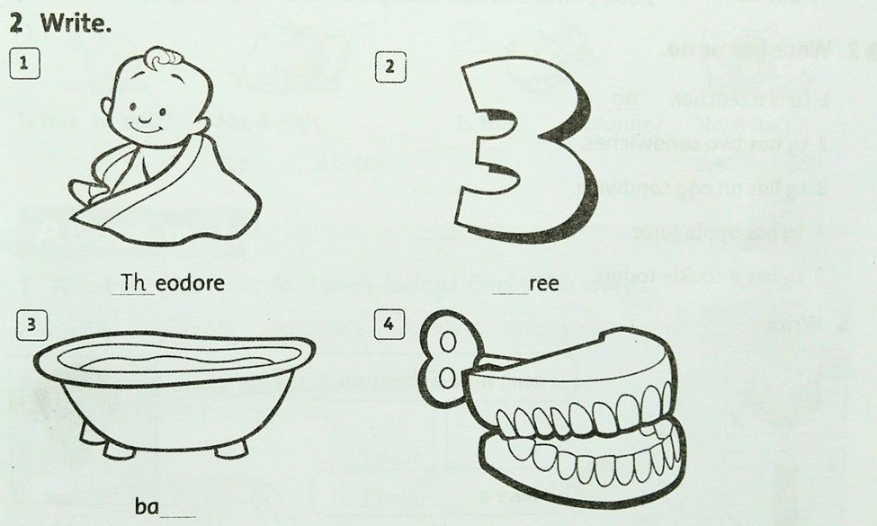

**3. Listen and write**

Baby Theodore ‘s in the _____________________.

One, two, ___________________.

Baby ___ ______________ counts his ___________.

One, two, ___________________.

**ANSWER KEYS**

**LESSON 1**

1. **Look at the picture and the letters. Write the words.**
2. lunchbox 2. drink 3. cookie 4. banana

5. sandwich 6. orange

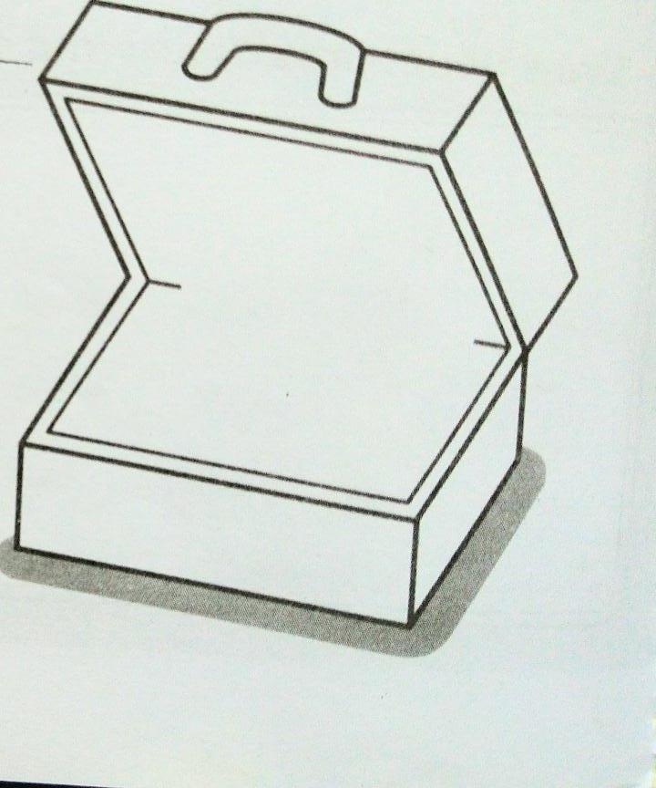**2. Write the words from 1. Then draw the food in the lunch box and match.**

1. This is a lunchbox.

2. This is a sandwich.

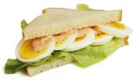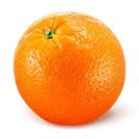3. This is a cookie,

4. This is a banana.

5. This is a drink.

6. This is an orange.

**LESSON 2**

1. **Write**
2. I have an apple.
3. I don’t have a sandwich.
4. I have a cookie.
5. I don’t have an orange.

**LESSON 3**

1. **Write and color:**  1. pear 2. grapes 3. tomato
2. **Look and write:**  1. tomato 2. apple 3. drink 4. sandwich
3. fish 6. banana 7. orange 8. lunchbox

**LESSON 4**



**2.Write**

1. Theodore 2. three 3. bath 4. teeth

1. **Listen and write**

Baby Theodore ‘s in the bath .

One, two, three.

Baby Theodore counts his teeth.

One, two, three.